Wind power
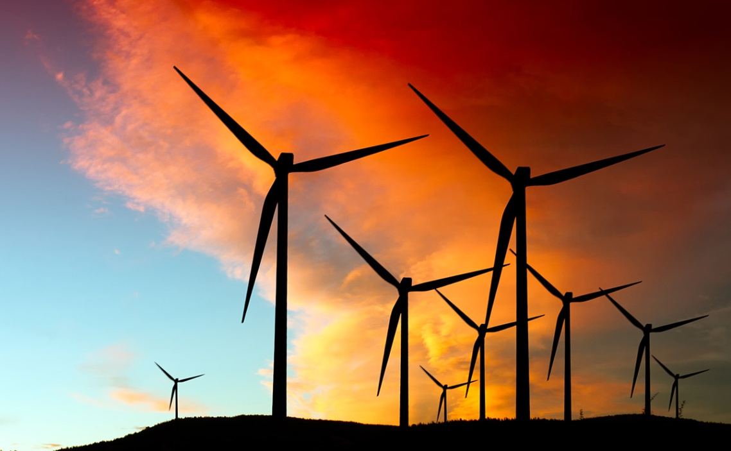
Wind power is the conversion of the energy in wind into a more useful form of energy, like electricity. It is a renewable source of energy that helps to cut down on the pollution of earth's air. Wind power is widely used in European countries, and more recently in the United States and Asia.

How it works
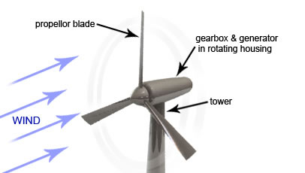
Wind power stations use the wind to turn a turbine which turns a magnet inside a coil. The wind has kinetic energy (movement energy) which is changed into mechanical energy by the blades on the turbine. The turbine then turns a generator which creates electrical energy. The turbine is usually connected by a gearbox to help control the speed it turns the generator at.

Soňa Dziaková 1.D

